A picture containing clipart

Description generated with very high confidence

Hands-on

Creating a Windows Shared File system and mounting it

AWS Solutions Architect

[**support@intellipaat.com**](mailto:support@intellipaat.com) **+91-7022374614 US: 1-800-216-8930(Toll Free)**

**Creating a Windows Shared File system and mounting it**

**Step 1:** Create an AWS Managed Microsoft AD before starting off with creating a File System

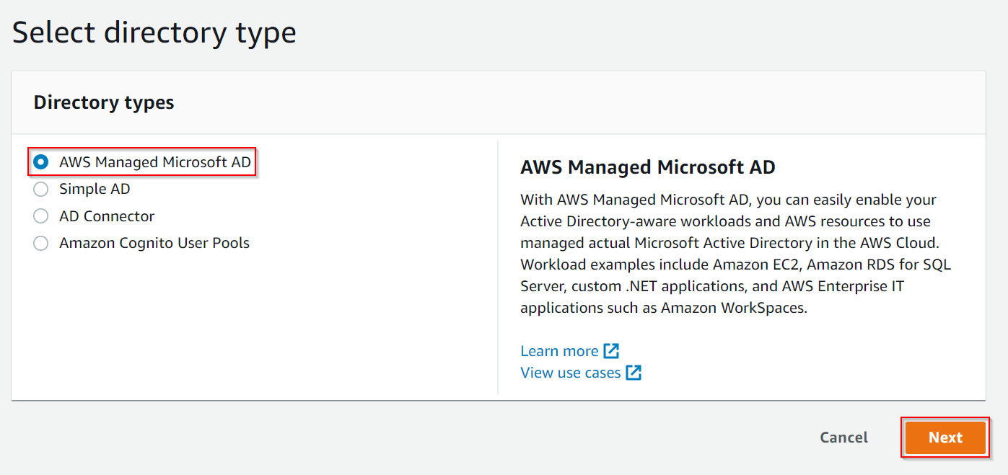

**Step 2:** Select Standard Edition as this is a practice

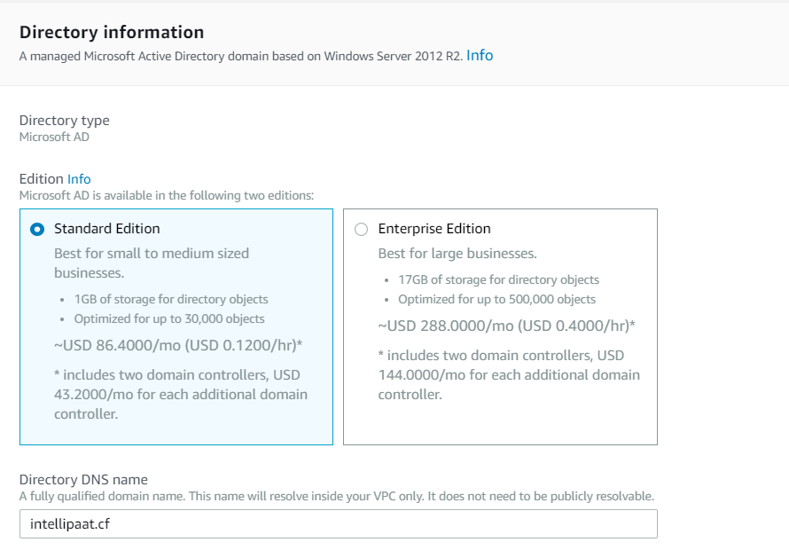

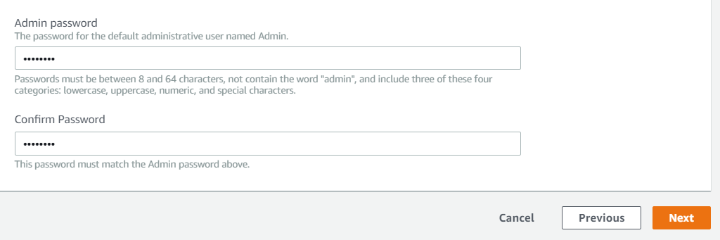

**Step 3:** Choose the VPC and subnets. Then click Next

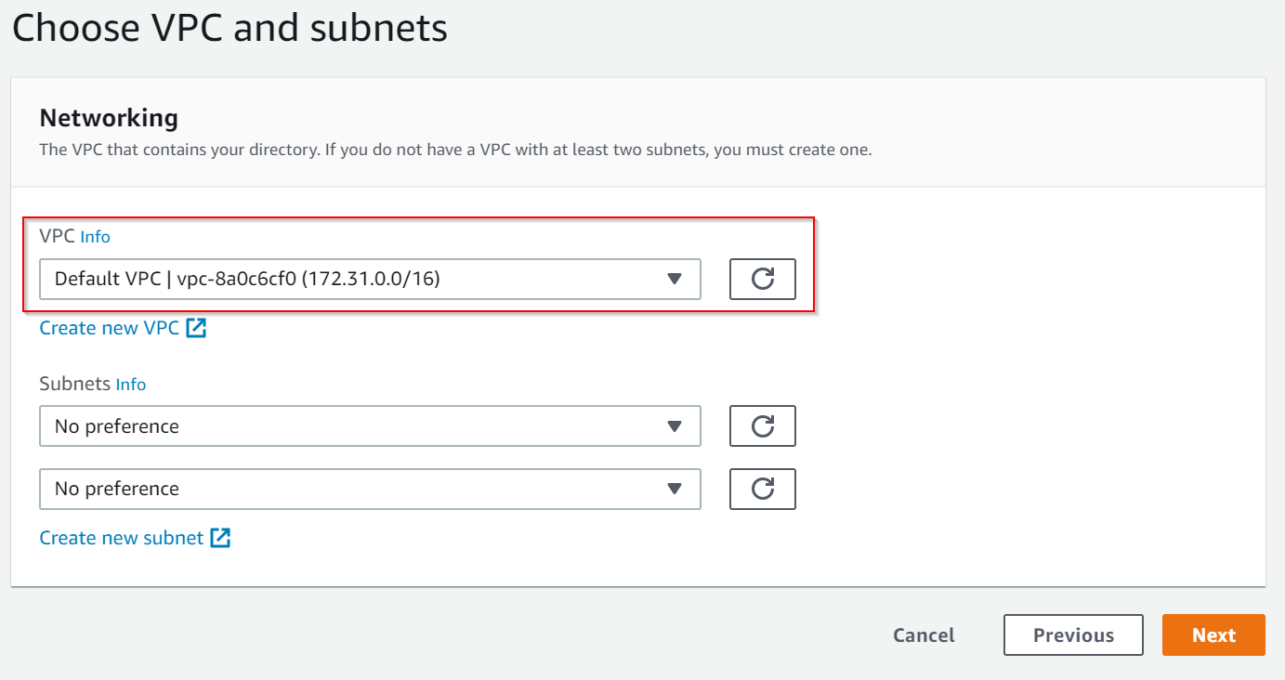

**Step 4:** This is a Free trail eligible directory. Do a quick review and click on Create directory. Will take 20 – 40 mins to create the directory.

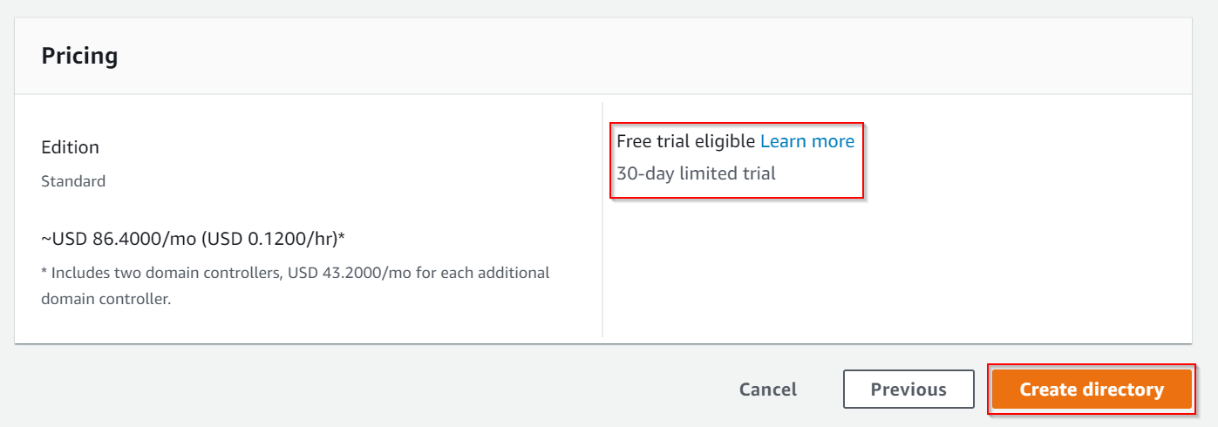

**Step 5:** Now, let’s create a FSx file system for Windows File Server

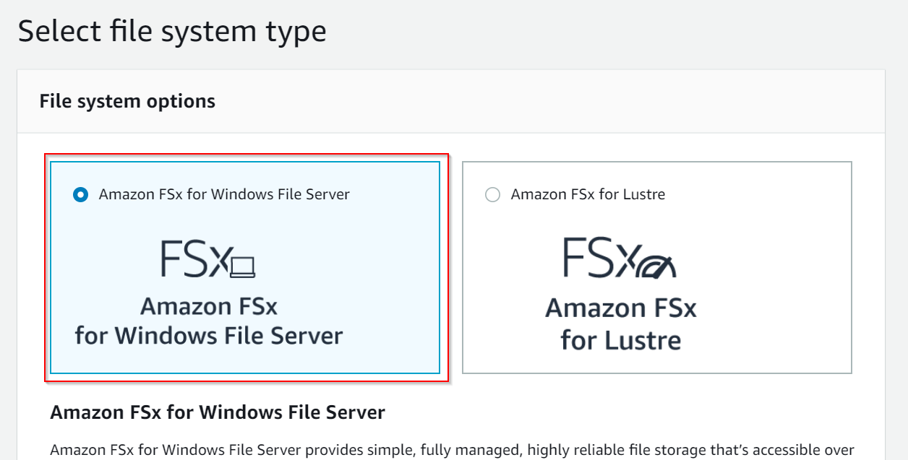

**Step 6:** Give a file system name, and choose the Multi-AZ or Single-AZ.

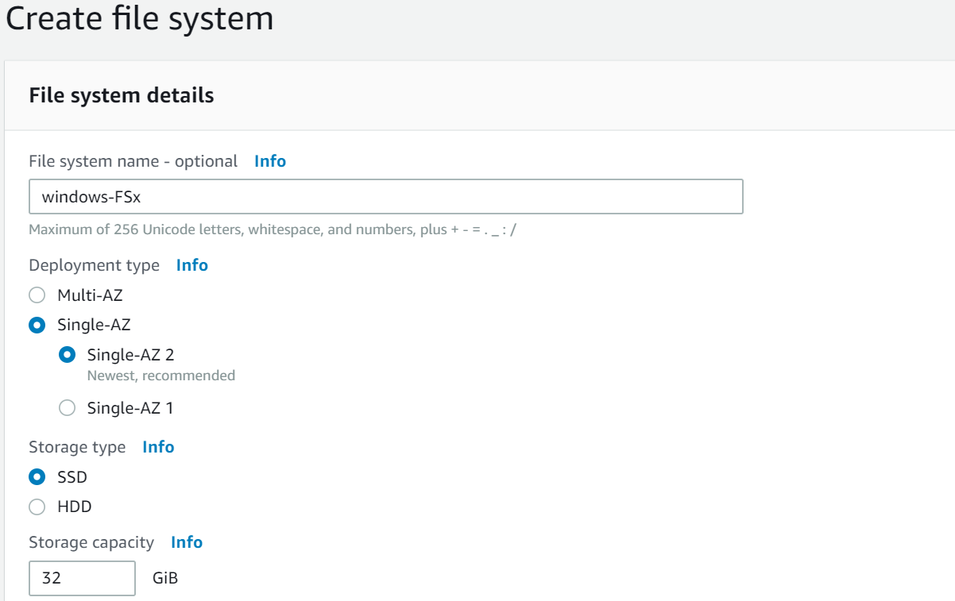

**Step 7:** Choose the Microsoft AD which got created now. The directory will only show after it is available.

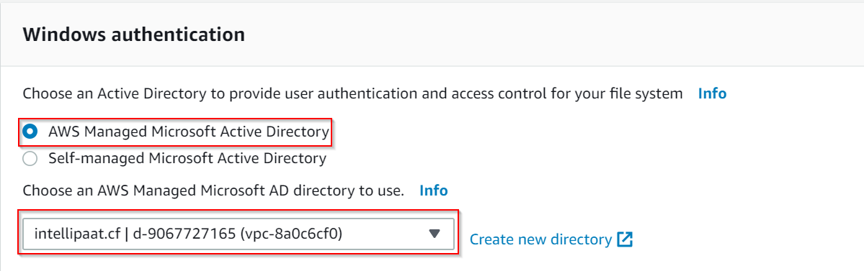

**Step 8:** Review and click on Create file system.

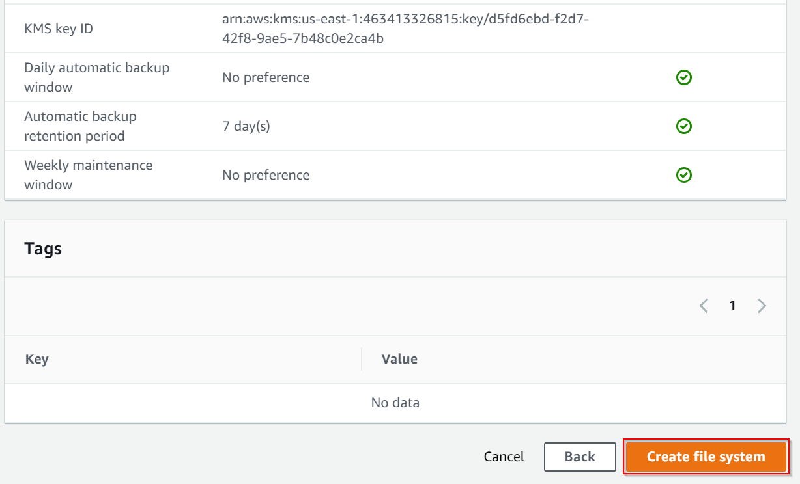

**Step 9:** Now, we are going to map the DNS address to a Windows instance. There is already have an instance up and running.

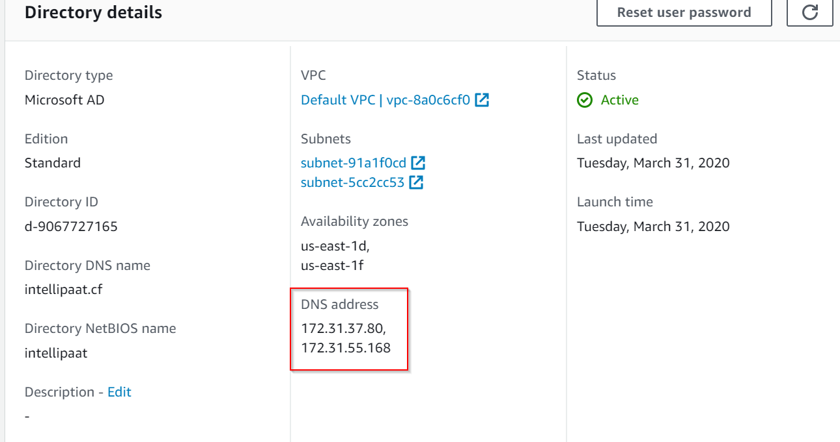

**Step 9:** Start your Windows instance. Go to Change Adapter Settings 🡪 Properties 🡪 Choose IPv4 and now you will be prompted the dialog box below. Enter the DNS server addresses here.

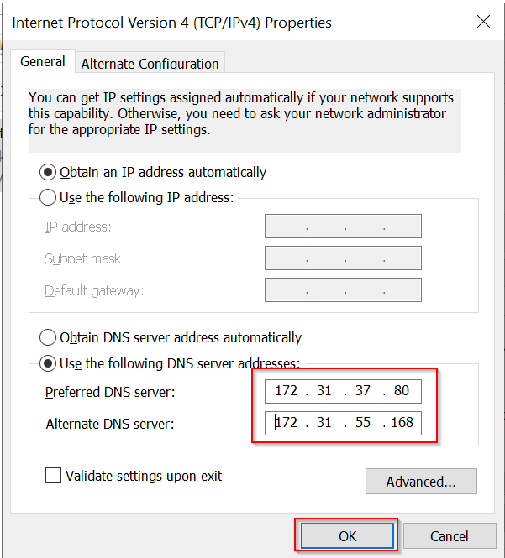

**Step 10:** After that, open System Properties and click Change

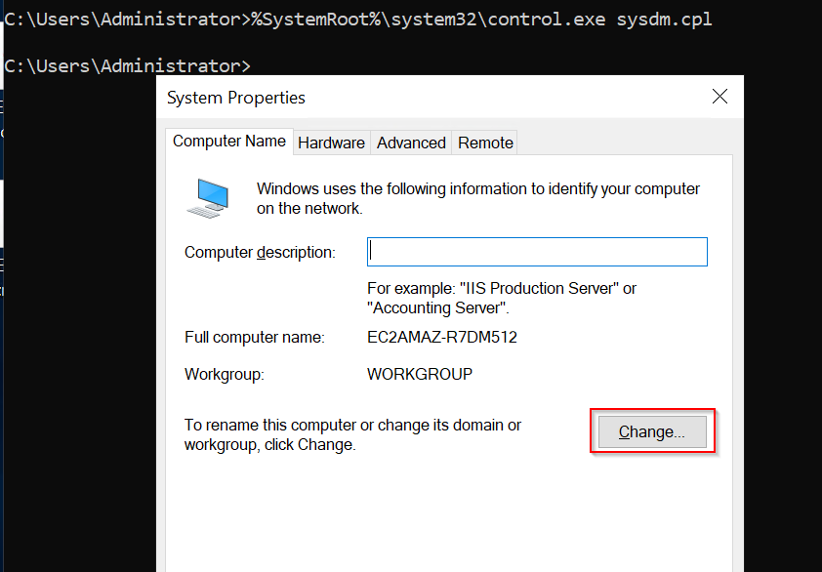

**Step 11:** Now, enter the domain name of your AD and then click OK

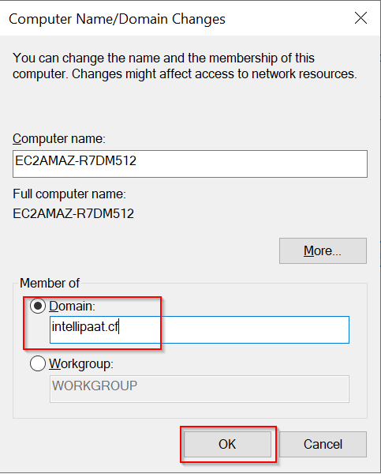

**Step 12:** You will be prompted to enter your username and password of your AD. Username is usually your **domainname/admin** (Which in this hands-on is intellipaat.cf/admin and then the password you entered while creating an AD). If it is successful, you get the below box.

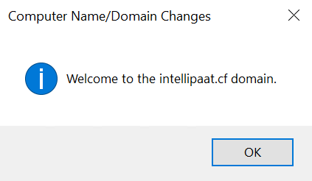

**Step 13:** We have successfully finished the first step here. Now, your PC would have rebooted. Open your Command Prompt and enter this – net use DriveLetter: \\fsxname.yourdomainname\share. DriveLetter is basically H: or any letter you want to provide.

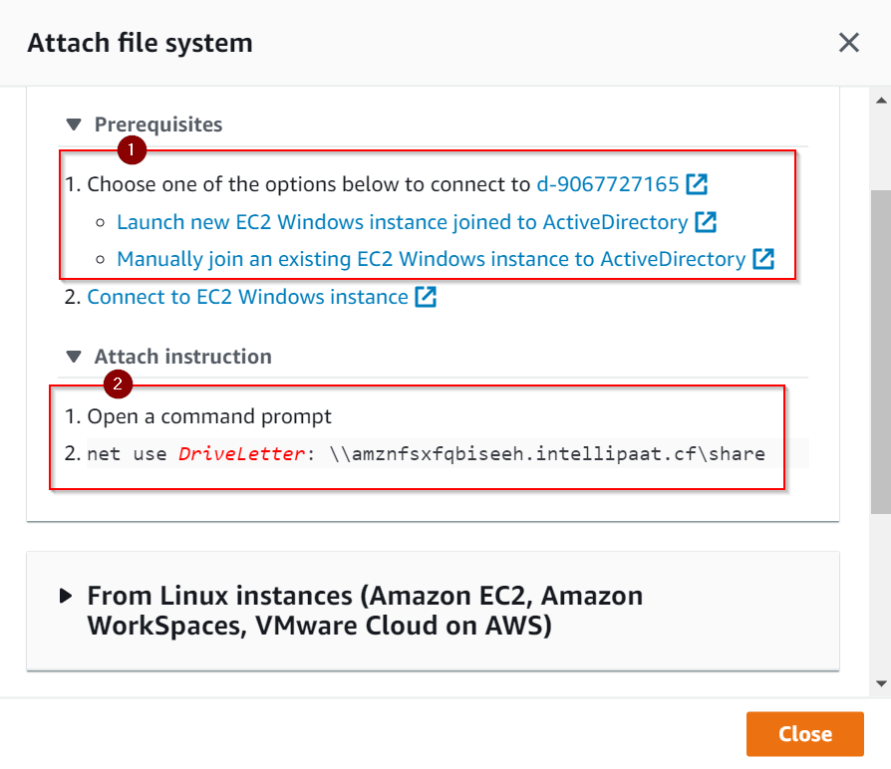

This is how you do the step I mentioned in the previous step.

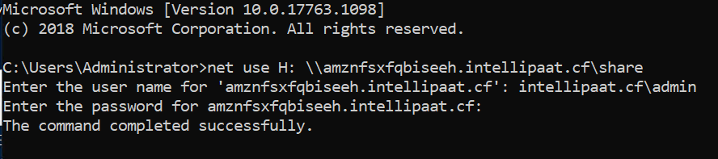

**Step 14:** We have successfully mounted the FSx file system!

